**SECD2523-10**

**DATABASE**

SEMESTER 1

SESSION 2023/2024

LAB 1 – DDL

Lecturer’s Name: Dr. ROZILAWATI

|  |  |
| --- | --- |
| Name | Student ID |
| PUVENTHIRAN A/L GANESON | A22EC0262 |

Date of submission : 12 NOVEMBER 2023

# Part 1: Reading information from a script

In this exercise you will use the “obl Sports.ddl” file to consolidate your knowledge of DDL. Open the “obl Sports.ddl” in a text editor.

1. How many tables have been created using the CREATE TABLE statement?

**10 tables**

1. How many columns are created for the price history table?

**6 columns**

1. What statement is used to enforce the constraint that the category column of the items table must have a value?

**NOT NULL**

1. What is the name of the foreign key constraint between the customers and customer addresses tables?

**ctr_number**

1. What are the lowest and highest values that can be stored in the commission_rate column for the sales_representatives table?

**lowest = -99, highest = 99**

1. What are the lowest and highest values that can be stored in the price column for the price_history table?

**lowest = -99999.99, highest = 99999.99**

1. What are the 3 columns that make up the primary key for the price_history table?

**itm_number, start_date, start_time**

**Part 2**: **Updating Constraints**

Log-in to APEX and go to the SQL commands environment

# Modifying a column

DESCRIBE orders;

ALTER TABLE orders

MODIFY odr_date DEFAULT SYSDATE;

DESCRIBE orders;

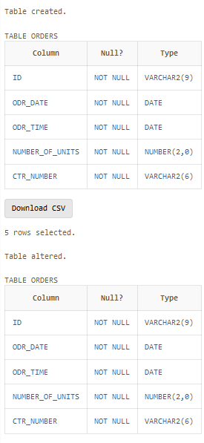

Adding a check constraint

DESCRIBE customers;

ALTER TABLE customers

ADD CONSTRAINT chk_current_balance CHECK (current_balance >= 0);

DESCRIBE customers;

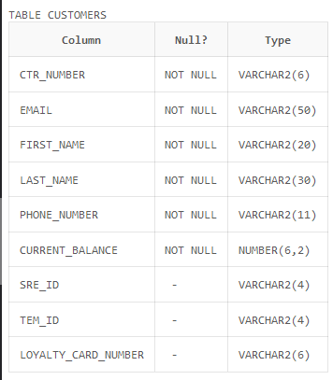

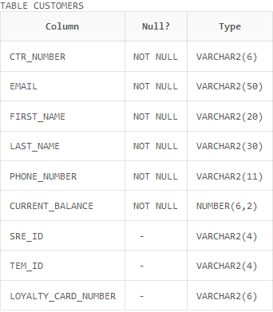

Adding a column

DESCRIBE customers;

ALTER TABLE customers

ADD mobile_number NUMBER(11);

DESCRIBE customers;  
  
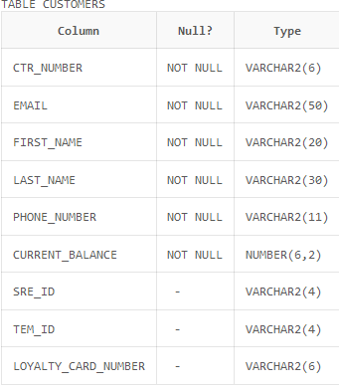

Dropping a column

DESCRIBE customers;

ALTER TABLE customers

DROP COLUMN mobile_number;

DESCRIBE customers;  
  
